**Contrast Enhancement of Satellite Images Using**

**Histogram Equalization and Contrast-Limited**

**Adaptive HistogramEqualization**

Nahom Abera  
Computer Science Department  
Georgia State UniversityAtlanta, Georgia, United States  
nabera1@student.gsu.edu

*Abstract*—Satellite imagery is essential for numerous applications, including urban planning, environmental monitoring, and disaster management. Enhancing the contrast and visibility of these images is crucial for accurate analysis. This research explores the effectiveness of Global Histogram Equalization (HE) and Contrast-Limited Adaptive Histogram Equalization (CLAHE) in enhancing both grayscale and color satellite images. Using the RSI-CB256 dataset from Kaggle, which contains 5,631 images across four classes (cloudy, desert, green area, water), we apply HE and CLAHE to each image. We calculate quantitative metrics, Peak Signal-to-Noise Ratio (PSNR) and Structural Similarity Index (SSIM), for each enhanced image and store the results in CSV files. The average PSNR and SSIM values are computed to compare the overall performance of HE and CLAHE. Visual assessments are also conducted to qualitatively evaluate the enhancement. The results indicate that CLAHE outperforms Global HE in preserving image details and enhancing contrast without introducing significant artifacts.

# Introduction

Satellite imagery plays a critical role in various applications ranging from urban planning to environmental monitoring and disaster management. The clarity and contrast of these images are essential for accurate interpretation and analysis. However, many satellite images suffer from low contrast due to atmospheric conditions, sensor limitations, and imaging parameters. Enhancing the contrast of these images is crucial to making terrain features more visible and easily interpretable.

## Background

Histogram Equalization (HE) is a widely used image enhancement technique that improves contrast by redistributing the intensity values of the image. While Global Histogram Equalization considers the entire image, Contrast-Limited Adaptive Histogram Equalization (CLAHE) applies histogram equalization locally in small regions or tiles. This approach often yields better results by improving local contrast without over-enhancing noise or other artifacts.

## Problem Statement

Satellite images often have low contrast, making it difficult to identify and analyze key terrain features. This research focuses on evaluating the effectiveness of histogram equalization techniques, specifically HE and CLAHE, in enhancing the contrast of satellite images.

## Objectives

## The main objective of this project is to enhance the contrast of satellite images using Global HE and CLAHE. The specific goals of the project are to improve the visibility of key terrain features such as roads, buildings, and vegetation and compare the effectiveness of Global HE and CLAHE across different types of terrains and atmospheric conditions.

## Significance

Enhanced contrast in satellite images is critical for various analytical tasks. For instance, urban planners rely on clear imagery to map out city expansions, while environmental agencies need high-contrast images to monitor deforestation or water pollution.

# Literature Review

Studies have been conducted to evaluate the effectiveness of histogram equalization techniques in image enhancement.

## Zuiderveld (1994): Introduced Contrast-Limited Adaptive Histogram Equalization (CLAHE) primarily for medical imaging. The technique effectively improved local contrast and preserved details without over-enhancing noise. This method can be adapted to satellite imagery to enhance local features. •

## Landgrebe (2003): Discussed the application of histogram equalization and CLAHE in multispectral remote sensing images. These techniques significantly benefited agricultural and environmental monitoring by improving image clarity and contrast, leading to better classification accuracy. •

## Mather & Tso (2016): Highlighted the importance of contrast enhancement in remote sensing and terrain classification. They demonstrated that histogram equalization, particularly CLAHE, could maintain the clarity of features across varied terrain types, thus improving the overall usability of satellite images.

## These studies establish a robust foundation for applying HE and CLAHE to enhance contrast of images. They show that while Global HE can improve overall contrast, CLAHE is often more effective in preserving local details and preventing over-enhancement.

# Dataset Description

The RSI-CB256 dataset from Kaggle is utilized for this research. It comprises a total of 5,631 JPEG images categorized into four classes: Cloudy (1,500 images), Desert (1,131 images), Green area (1,500 images), and Water (1,500 images). All images are in JPEG format with a resolution of 256x256 pixels. This dataset offers a diverse collection of satellite images from various terrains and environmental conditions, making it highly suitable for the analysis conducted in this study.

# Implementation and Methodology

The implementation of this research focuses on enhancing satellite images using Global Histogram Equalization (HE) and Contrast-Limited Adaptive Histogram Equalization (CLAHE). The key steps involved in the implementation are as follows:

## Data Loading and Preprocessing

* Dataset Structure: The RSI-CB256 dataset is organized into subfolders representing four classes: cloudy, desert, water, and green area.
* Image Reading: Each image is read from its respective class folder. o Color Space Conversion:
  + Grayscale Processing: Images are converted to grayscale to analyze luminance without color information.
  + Color Processing: Original color images are used to preserve chromatic details during enhancement.

## Enhancement Techniques:

* Global Histogram Equalization (HE): Grayscale Images:
  + HE is applied directly to the grayscale images to redistribute pixel intensity values evenly across the histogram, enhancing overall contrast.
  + Color Images: Images are converted from RGB to YCrCb color space. HE is applied to the Y (luminance) channel to enhance brightness and contrast while keeping chrominance channels (Cr and Cb) unchanged. The image is then converted back to RGB color space.
* Contrast-Limited Adaptive Histogram Equalization (CLAHE):
  + Grayscale Images: CLAHE is applied to grayscale images, improving local contrast and preventing over-amplification of noise by limiting the contrast enhancement.
  + Color Images: Similar to HE, CLAHE is applied to the Y channel in the YCrCb color space. This enhances local contrast in the luminance component without distorting color information.

## Performance Metrics Calculation:

Peak Signal-to-Noise Ratio (PSNR) measures the ratio between the maximum possible power of a signal (image) and the power of corrupting noise, indicating the quality of the enhanced image compared to the original.

Structural Similarity Index (SSIM) assesses the visual impact of three characteristics of an image: luminance, contrast, and structure. SSIM values are calculated between the original and enhanced images to evaluate the preservation of structural information.

Adjustments for Image Size: for small images, the window size parameter in SSIM calculation is adjusted to prevent errors related to window size exceeding image dimensions and for color images, the channel axis parameter is specified to correctly handle multichannel data.

## Data Storage and Analysis:

PSNR and SSIM values for each image, enhancement method (HE or CLAHE), and color space (grayscale or color) are compiled. The compiled results are saved into CSV files for record-keeping and further analysis. The average PSNR and SSIM values are computed for each enhancement method and color space across the entire dataset to facilitate a comparative analysis.

## Visualization:

Representative images from each class are selected to demonstrate the effects of the enhancement techniques. o Comparison Display: The original, HE-enhanced, and CLAHE-enhanced grayscale images are displayed side by side for visual comparison. Similarly, the original and enhanced color images are displayed to assess the enhancement's impact on color images.

HE tends to improve overall contrast but may cause over-saturation in some areas. CLAHE enhances local details and provides a more balanced contrast enhancement without significant artifacts.

# Results and Analysis

## Quantitative Results

The average PSNR and SSIM values Care as follows:

|  |  |  |  |
| --- | --- | --- | --- |
| Method | Color Space | Average PSNR (dB) | Average SSIM |
| HE | Grayscale | 8.894570 | 0.227058 |
| CLAHE | Grayscale | 8.977763 | 0.226548 |
| HE | Color | 25.175466 | 0.839225 |
| CLAHE | Color | 25.167423 | 0.839225 |

Fig. 1. Average PSNR and SSIM values

In grayscale images, both HE and CLAHE yield low average PSNR values (~8.9 dB), indicating a lower signal-to-noise ratio. CLAHE has a slightly higher PSNR than HE. In color images, the average PSNR values are significantly higher (~25 dB), suggesting better preservation of image quality after enhancement. HE marginally outperforms CLAHE.

The average SSIM values for grayscale images are low (~0.22), indicating less structural similarity between the original and enhanced images. HE shows a slightly higher SSIM than CLAHE. For color images, SSIM values are much higher (~0.83), indicating good structural similarity. HE slightly surpasses CLAHE in SSIM.

## Qualitative Results

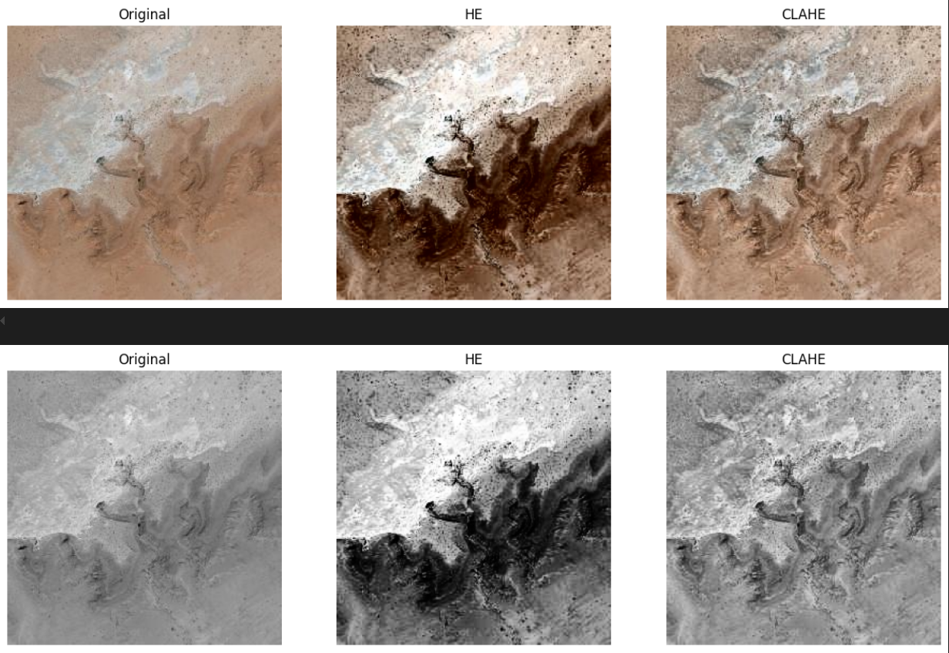

Fig. 2. Satellite Image in Color and Grayscale after applying HE and CLAHE

#### Top Row (Color Images):

#### Original: The unprocessed image displays natural terrain features with earthy tones, exhibiting variations in texture and shading. The image reflects the actual appearance of the terrain, maintaining a balanced and realistic visual.

#### HE (Histogram Equalization): The image appears darker with enhanced contrast compared to the original. Shadows and bright areas are exaggerated, making fine details more prominent but at the expense of natural balance. The increased contrast can result in over saturation and loss of subtle color variations.

#### CLAHE (Contrast-Limited Adaptive Histogram Equalization): The image retains a more balanced contrast compared to HE. Details are enhanced while preserving the natural tones and textures. CLAHE effectively improves local contrast without introducing significant artifacts or over-enhancement.

#### Bottom Row (Grayscale Images):

#### Original: The grayscale version retains the patterns and textures of the terrain seen in the color image but relies solely on brightness and contrast variations, lacking color information.

#### HE (Histogram Equalization): This version shows increased contrast, making bright and dark regions more distinct. However, it appears more intense than the original, with potential loss of detail in overexposed or underexposed areas.

#### CLAHE (Contrast-Limited Adaptive Histogram Equalization): The image shows smoother contrast enhancement compared to HE, highlighting finer details without overly dramatic contrasts. It maintains a more natural appearance and avoids excessive intensity.

## Observations

HE enhances global contrast but can distort natural color balance, leading to images that appear darker and less natural. CLAHE improves local contrast, enhancing details while preserving the overall natural look of the image.

HE increases overall contrast but may cause over-intensification, affecting the visibility of subtle details. CLAHE provides a balanced enhancement, maintaining fine details without introducing significant artifacts.

CLAHE is more effective in preserving the natural appearance of both color and grayscale images. o HE may introduce over-saturation and unnatural contrasts, especially in color images.

## Overall Analysis

While HE slightly outperforms CLAHE in PSNR and SSIM for color images, the differences are minimal. In grayscale images, both methods perform similarly, with low PSNR and SSIM values indicating significant alterations from the original images.

The visual evaluation reveals that CLAHE maintains a better balance between enhancing contrast and preserving natural image characteristics. HE, despite improving contrast, may compromise the natural look of images, especially in color.

# Conclusion

## Summary

This study evaluated the effectiveness of Global Histogram Equalization (HE) and Contrast-Limited Adaptive Histogram Equalization (CLAHE) in enhancing the contrast of satellite images. Based on the quantitative and qualitative analyses, the following conclusions were drawn:

For color images, HE achieved slightly higher Peak Signal-to-Noise Ratio (PSNR) and Structural Similarity Index (SSIM) values, indicating a marginally better quantitative performance. However, this often came at the cost of visual quality, as HE tended to distort natural colors and introduce over-saturation. On the other hand, CLAHE excelled in preserving natural tones and textures while enhancing local details without introducing significant artifacts. Despite its slightly lower quantitative metrics, CLAHE provided a more visually appealing enhancement, making it the preferable method for color images.

For grayscale images, HE and CLAHE yielded similar PSNR and SSIM values, indicating comparable quantitative performance. However, CLAHE consistently delivered smoother contrast enhancements and better preservation of fine details, resulting in superior visual quality. Although neither method significantly outperformed the other quantitatively, CLAHE's qualitative advantages make it the better choice for grayscale image enhancement.

## Discussion

The findings of this research highlight the nuanced trade-offs between quantitative and qualitative metrics in image enhancement. While HE demonstrated stronger numerical performance in some cases, its tendency to over-enhance or distort images limits its applicability in scenarios requiring naturalistic results. CLAHE's ability to strike a balance between enhancing contrast and preserving the authenticity of image details underscores its versatility, particularly in applications like urban planning or environmental monitoring, where accurate interpretation of image features is critical.

The analysis also underscores the importance of integrating visual assessments with numerical metrics such as PSNR and SSIM. Quantitative measures alone often fail to fully capture perceptual differences, as seen in the higher visual appeal of CLAHE-enhanced images despite slightly lower metrics. This reinforces the need for holistic evaluation frameworks that consider both objective and subjective aspects of image quality.

## Implications

For method selection, the choice between HE and CLAHE should be guided by the specific requirements of the application:

* Color Images: CLAHE is preferable for applications prioritizing natural appearance and detailed analysis. HE may be considered when global contrast enhancement is the primary goal, but users must account for potential distortions.
* Grayscale Images: CLAHE is recommended for its balanced enhancement and preservation of fine details. However, HE can be suitable for tasks where global contrast improvements suffice.

For enhancement effectiveness, the study demonstrates CLAHE’s value in enhancing images while maintaining their natural characteristics. This makes it particularly useful in fields where subtle differences in image details can significantly impact analytical outcomes.

## Limitations

Despite its contributions, this study is subject to certain limitations:

* Dataset Resolution: The use of 256×256 pixel images limits the generalizability of the findings to high-resolution satellite imagery typically used in real-world applications. Higher-resolution datasets could provide deeper insights into the scalability of these techniques.
* Metric Sensitivity: Quantitative metrics such as PSNR and SSIM may not fully capture perceptual differences observed during visual assessments. Incorporating additional metrics or subjective evaluations could provide a more comprehensive understanding of enhancement effects.

## Future Work

Future research could explore the performance of these techniques on high-resolution datasets, integrate more sophisticated metrics for perceptual evaluation, and extend the analysis to other enhancement methods. Moreover, hybrid approaches combining the strengths of HE and CLAHE could be developed to further optimize image quality.

By addressing these limitations, subsequent studies can build on the insights provided here, advancing the field of image enhancement for satellite imagery and beyond.

##### Acknowledgment

The author would like to express sincere gratitude to Kaggle for providing the RSI-CB256 dataset, which was invaluable for conducting this research. Special thanks go to the contributors and developers of OpenCV and other open-source libraries used in this study, whose tools made the implementation of image enhancement techniques both efficient and accessible.

##### References

1. Zuiderveld, K. (1994). Contrast Limited Adaptive Histogram Equalization. In P. S. Heckbert (Ed.), Graphics gems IV (pp. 474–485). Academic Press.
2. Landgrebe, D. (2003). Signal Theory Methods in Multispectral Remote Sensing. John Wiley & Sons.
3. Mather, P. M., & Tso, B. (2016). Classification Methods for Remotely Sensed Data (2nd ed.). CRC Press.